Industrial Technology 4.0 Base Robotic Arm

Dhangar Sumedh, Dipti More, Dakshak Patil

Prof.Mundhe B.B.

Department of AI DS Engineering, Jai hind College of Engineering, Kuran Email: DhangarSumedh82@gmail.com

Department of AI DS Engineering, Jai hind College of Engineering, Kuran Email: diptimore8486@gmail.com

Department of AI DS Engineering, Jai hind College of Engineering, Kuran Email: Dakshakpatil22@gmail.com

Department of AI DS Engineering, Jai hind College of Engineering, Kuran Email: mundheraj.mundhe@gmail.com

________________________________________________________________________________________________________

***Abstract:***The emergence of Industry 4.0 has revolutionized manufacturing processes through the integration of advanced technologies such as the Internet of Things (IoT), artificial intelligence (AI), and big data analytics. This abstract presents the development of an Industry 4.0-based robotic arm designed to enhance flexibility, efficiency, and precision in industrial operations. Unlike traditional robotic systems that are limited to fixed tasks, this robotic arm utilizes real- time data and adaptive algorithms to respond to dynamic production environments. By lever- aging IoT connectivity, the robotic arm can communicate with other machines, enabling seam-less integration into smart factory ecosystems. Additionally, AI algorithms allow for predictive maintenance and improved decision-making capabilities, ensuring optimal performance and re- deuced downtime. This innovative approach not only addresses the challenges of customization and scalability in modern manufacturing but also sets the foundation for a more intelligent and responsive industrial landscape. The proposed robotic arm serves as a critical component in advancing automation and promoting sustainable practices in the era of Industry 4.0.

***Index Terms-***: **Hand Gesture, Voice Recognisation,Camera, Controller, Communication.**

*________________________________________________________________________________________________________*

# **Introduction**

Robotic arms have been a staple in manufacturing for decades, but the advent of Industry 4.0 has ushered in a new era of robotic technology, transforming the way we produce goods. Industry 4.0, also known as the Fourth Industrial Revolution, is characterized by the convergence of physical and digital technologies, leading to the creation of smart factories. These factories are equipped with interconnected devices, machines, and systems that communicate and collaborate to optimize production processes.Robotic arms are already being used in various industrial settings, performing tasks that are repetitive, dangerous, or require high precision. However, recent advancements in artificial intelligence, machine learning, and human-machine interfaces are expanding their capabilities and making them more accessible for people with disabilities.

Robotic arms are typically equipped with sensors and actuators that allow them to interact with their environment. They can be programmed to perform specific tasks, such as welding, assembly, painting, and materials handling. Industrial robotic arms are often used in manufacturing plants to automate tasks that are repetitive, dangerous, or require a high degree of precision. That enable them to interact with the environment in a safe and efficient manner. They can be programmed to perform a wide range of tasks, such as reaching for objects, grasping and manipulating them, and even moving them from one place to another.

# **PROBLEM STATEMENT**

Despite the potential benefits of robotic arms for disabled people, there are still a number of challenges that need to be overcome before these technologies can be widely adopted. These challenges include the high cost of robotic arms, the need for specialized training, and the limitations of robotic arms in terms of functionality. As a result, many disabled people continue to face significant challenges in performing everyday tasks.

# **OBJECTIVES**

Robotics is rapidly evolving, with the advent of Industry 4.0 technologies enabling the development of sophisticated robotic systems. These systems hold immense potential to revolutionize various aspects of society, including healthcare, education, and manufacturing. In particular, the integration of robotics with assistive technologies presents exciting opportunities to enhance the quality of life for individuals with disabilities.

# **METHODOLOGY**

* 1. **Algorithm**

The system’s workflow is broken down into four key steps, as outlined below:

1. **User choices:**

User having some operarion to choose for process: -

1.Voice System.

2.Gesture System.

3.Controller.

1. **Voice System:** Voice systems, often referred to as speech recognition or speech-to-text systems, employ a combination of techniques to convert spoken language into written text. These systems have become increasingly prevalent in various applications, from virtual assistants to transcription services.
2. **Gesture System :** A gesture system algorithm is a computational process designed to recognize and interpret human gestures from various input sources, such as cameras, depth sensors, or wearable devices. These algorithms play a crucial role in fields like human-computer interaction (HCI), robotics, and augmented reality.
3. **Action Execution:**

For a robotic arm involves the process of translating a desired task or motion into a sequence of commands that the arm can understand and carry out. This process typically involves several key steps:

1. Task Planning:
2. Motion Control:
3. Sensor-Based Control:
4. Human-Robot Collaboration:

# **WORKFLOW**

figure 1. workflow

* The workflow diagram represents a system Start The system initiates. User Choice The user selects their preferred input method voice or gesture. Input Processing If the user chooses voice, the system processes the voice input using a voice recognition algorithm. If the user chooses gesture, the system processes the gesture input using a gesture recognition algorithm and using of controller. Output The system generates an output based on the processed input (either voice or gesture).

# **SYSTEM ARCHITECTURE**

* **Input Modules:**

Voice System: Responsible for capturing and processing voice input.

Gesture System: Responsible for capturing and processing gesture input.

Controller: Responsible for Capturing and process of controll

* **Algorithms:**

Voice Algorithm: Processes voice input to extract meaning or intent.

Gesture Algorithm: Processes gesture input to recognize specific gestures or actions.

Controller: Processes of actuator and perform into big model.

* **Output Module:**

Responsible for generating the final output (e.g., controlling a device, providing information).

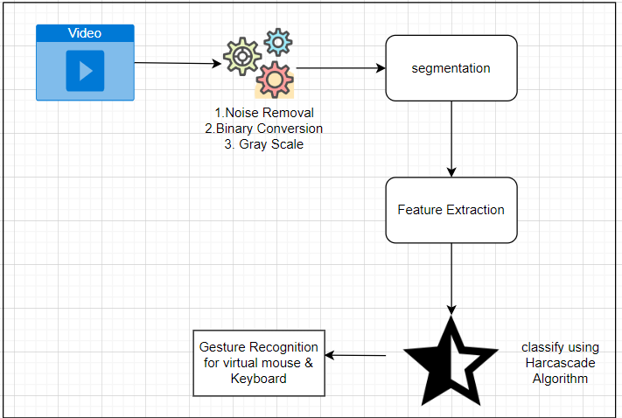

figure 2. system architecture

**6.3 Input Modules:**

The input module is a crucial component of any gesture-based control system, responsible for capturing and processing raw data from various sensors. This data serves as the foundation for subsequent gesture recognition and interpretation.

* 1. **Classification:**

The development of robotic arms that can be controlled through voice, gesture, or a controller system is an active area of research and development within the field of Industry 4.0.

* Voice-based input algorithms:
* Gesture-based input algorithms:
* Controller-based input algorithms:

# **CONCLUSION**

Industry 4.0 robotic arms are playing a vital role in transforming the manufacturing industry. By combining advanced technologies such as sensing, AI, and connectivity, these robotic arms are enabling manufacturers to achieve greater productivity, quality, and flexibility. As Industry 4.0 continues to evolve, we can expect to see even more sophisticated and versatile robotic arms being deployed in factories around the world. This thing we are going in use in personal life disabled peopled as well as well fit & fine people.

# **FUTURE SCOPE**

Robotics is rapidly evolving, with Industry 4.0 technologies enabling increasingly sophisticated and versatile robotic systems. This has significant implications for individuals with disabilities, as robotic arms have the potential to revolutionize their daily lives by providing greater independence, functionality, and quality of life.Robotic arms could assist with activities of daily living (ADLs) such as feeding, dressing, grooming, and bathing, enabling individuals with limited mobility or dexterity to perform these tasks more independently.

Robotic arms could be used to control household appliances, open doors, or operate computers, giving individuals with disabilities greater control over their environment. Robotic arms could be integrated with wheelchairs or exoskeletons to provide additional support for movement, allowing people with disabilities to navigate their surroundings more easily.

# **REFERENCES**

1. Luis Roda-Sancheza,Teresa Olivaresa,Celia Garrido-Hidalgoa ,Jos´ e Luis de la Varaa,and Antonio Fern´ andez-Caballero.”Human-robot interaction in Industry 4.0 based on an Inter- net of Things real-time gesture control system”. Integrated Computer-Aided Engineering 28 (2024)
2. Arianna Martinelli,1 Andrea Mina2,1 and Massimo Moggi3” The enabling technologies of industry 4.0: examining the seeds of the fourth industrial revolution". Industrial and Corporate Change, 2022
3. XUN YE, SEUNG HO HONG, (Senior Member, IEEE). An Industry 4.0 Asset Administ- traction Shell-Enabled Digital Solution for Robot-Based Manufacturing Systems. date of publication November 16, 2021
4. K. T. Park, J. Yang, and S. D. Noh, “VREDI: Virtual representation for a digital twin application in a work-center-level asset administration shell,” J. Intell. Manuf., vol. 32, no. 2, pp. 501–544, Feb. 2021, do: 10.1007/s10845-020-01586-x.
5. HAI-WU LEE, (Member, IEEE). The Study of Mechanical Arm and Intelligent Robot. Digital Object Identifier 10.1109/ACCESS.2020
6. Mar´ ıa del Carmen Lucas-Esta˜ Baldomero Coll-Perales. Redundancy and Diversity in Wire-less Networks to Support Mobile Industrial Applications in Industry 4.0. Article in IEEE Transactions on Industrial Informatics · March 2020
7. C. Hildebrandt, A. Kocher, C. Kustner, C.-M. Lopez-Enriquez, A. W. M´’uller, B. Cae-Sar, C. S. Gundlach, and A. Fay, “Ontology building for cyber–physical systems: Application in the manufacturing domain,” IEEE Trans. Autom. Sci. Eng., vol. 17, no. 3, pp. 1266–1282, Jul. 2020, Doi: 10.1109/TASE.2020.2991777.
8. Industrial-Process Measurement, Control and Automation-Asset Administration Shell for industrial Applications—Part 1: Administration Shell Structure, document IEC 63278-1, 2020.
9. H. Tang, D. Li, J. Wan, M. Imran, and M. Shoaib, “A reconfigurable method for intelligent manufacturing based on industrial cloud and edge intelligence,” IEEE Internet Things J., vol. 7, no. 5, pp. 4248–4259, May 2020, Doi: 10.1109/JIOT.2019.2950048.
10. M. Platenius-Mohr, S. Malakuti, S. Gr¨ aner, J. Schmitt, and T. Goldschmidt, “File- and API-based interoperability of digital twins by model transformation: An IIoT case study using asset administration shell,” Future Gener. Comput. Syst., vol. 113, pp. 94–105, Dec. 2020, Doi: 10.1016/j.future.2020.07.004.